Project Deliverable

For the individual project, I want to create a website which you can buy flight tickets on it. For the main page, I will create a header which shows the name of the flight company. For the section of content, I will have three elements include body and main which shows the route of the flight, images of airplanes and the price of the flight tickets (I will get these contents mainly from Google and other websites related to it). Furthermore, I will have section element to show extra information and footer element to show the copyright of the website.

Description of Site Map:

1. For my homepage, I want to show that where customers can book tickets with one link. The second show the travel information which can help customers to get ready for trip, and the last link is about some special requests.
2. Three side pages related to homepage can help customers to book their tickets and some pre-flight and post-flight considerations. Also,

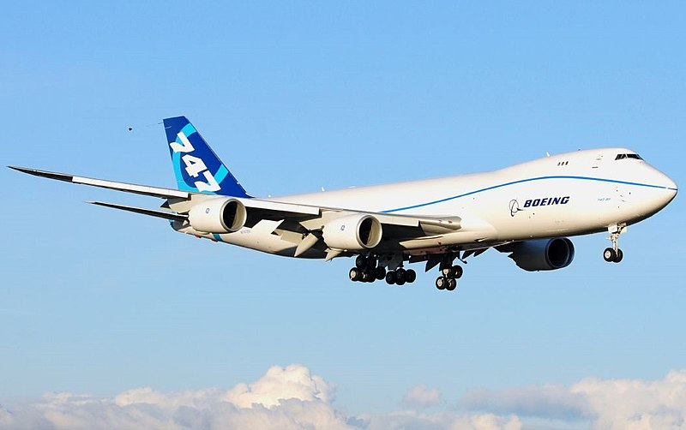

<https://zh.m.wikipedia.org/wiki/File:Boeing_747-8_N747EX_First_Flight.jpg> (Boeing 747))

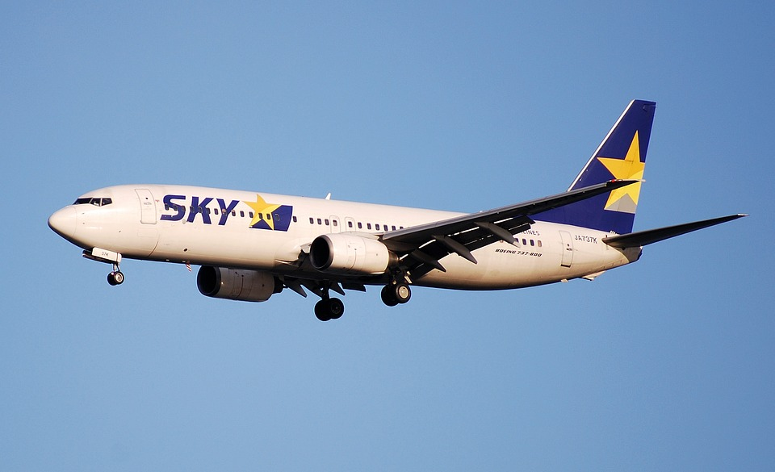

<https://pixabay.com/photos/boeing-737-sky-airplane-jet-884435/> (Boeing 737)

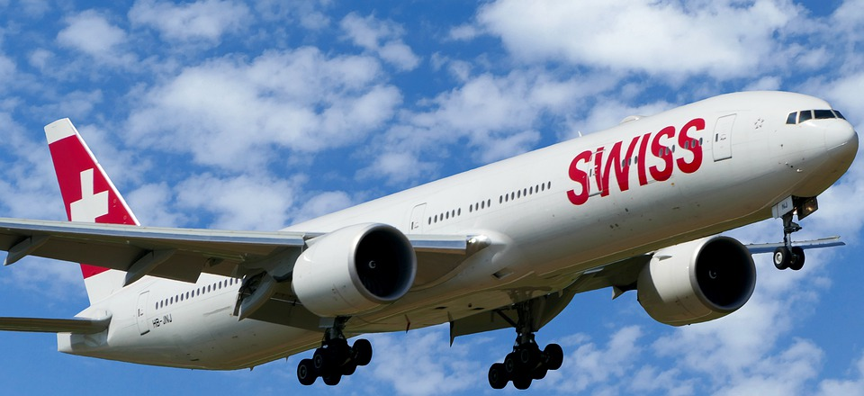

<https://pixabay.com/photos/zurich-swiss-landing-boeing-777-300-4366116/> (Boeing 777)

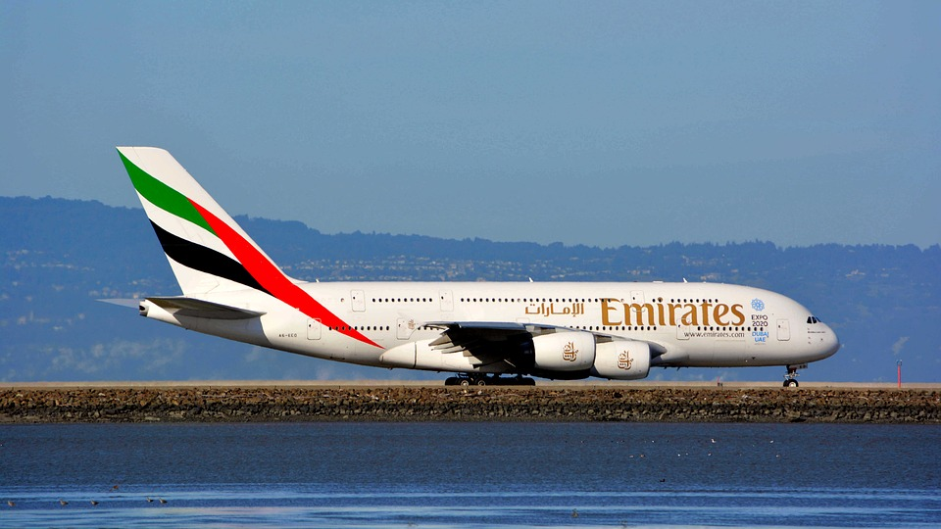

<https://pixabay.com/photos/uae-planes-airplanes-airbus-4145653/> （A380）

**Table of contents:**

|  |  |  |  |  |
| --- | --- | --- | --- | --- |
|  | Filename | Source | Owner | Reuse |
| Image 1 | Boeing 747 | <https://zh.m.wikipedia.org/wiki/File:Boeing_747-8_N747EX_First_Flight.jpg> | Unknown | Yes |
| Image 2 | Boeing 737 | <https://pixabay.com/photos/boeing-737-sky-airplane-jet-884435/> | Sky Airline | Yes |
| Image 3 | Boeing 777 | <https://pixabay.com/photos/zurich-swiss-landing-boeing-777-300-4366116/> | Swiss Airline | Yes |
| Image 4 | A380 | <https://pixabay.com/photos/uae-planes-airplanes-airbus-4145653/> | Emirates Airline | Yes |
| Media | Background music | https://www.youtube.com/watch?v=4sadzro9JhQ | Plow Music | Yes |